**Code Challenge (Below)**

 Below is the code challenge but before you start work on please **read the following articles** which provide excellent advice on how to deliver a successful solution.  If you read these articles, follow the advice provided and **continually refer back to them during the development process** you should be able to deliver a quality solution which will secure the next and final step - a technical interview.   These articles are essential reading as **your solution to this challenge must be perfect**.  Use of Design Patterns, Notations, Syntax, ReadMe file, FULL Test Coverage & Unit Tests, a Swagger Spec. – everything has to be perfect.  If not, there will be no technical interview.  So before you get to work do read the following 2 articles.

<https://www.codementor.io/learn-programming/9-essential-tips-tackle-coding-challenge>

<https://www.fullstackinterviewing.com/2018/02/02/the-ultimate-guide-to-kicking-ass-on-take-home-coding-challenges.html>

**CODE CHALLENGE**

You’re asked to write a program in Java which determines if two cities are connected.

Two cities are considered connected if there’s a series of roads that can be traveled from one city to another.

List of roads is available in a file.

File contains a list of city pairs (one pair per line, comma separated), which indicates that there’s a road between those cities.

It will be deployed as a spring-boot app and expose one endpoint:

<http://localhost:8080/connected?origin=city1&destination=city2>

Your program should respond with ‘yes’ if city1 is connected to city2, ’no’ if city1 is not connected to city2.

Any unexpected input should result in a ’no’ response.

*Example:*

city.txt content is:

Boston, New York

Philadelphia, Newark

Newark, Boston

Trenton, Albany

<http://localhost:8080/connected?origin=Boston&destination=Newark>

Should return yes

<http://localhost:8080/connected?origin=Boston&destination>=Philadelphia

Should return yes

<http://localhost:8080/connected?origin=Philadelphia&destination=Albany>

Should return no

**USER GUIDE NOTES FOR CITY CONNECTION SERVICE**

* CITY Connection Service – read the cities from the file – “src/main/resources/CityConnect.txt. The file has entries as under –

Boston, New York

Philadelphia, Newark

Newark, Boston

Trenton, Albany

Boston,Chicago

New York,Princeton

Trenton, New York

* Build the program:

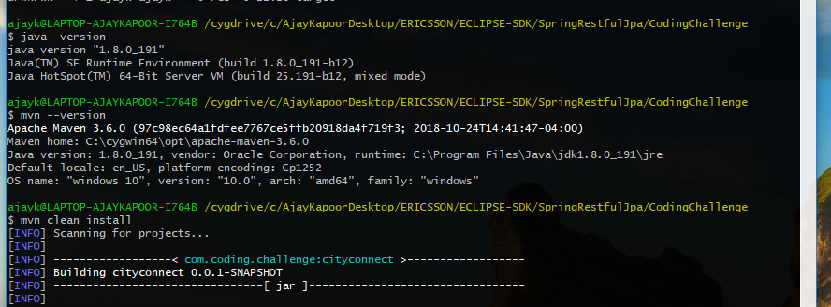

* Run the Spring Boot Application

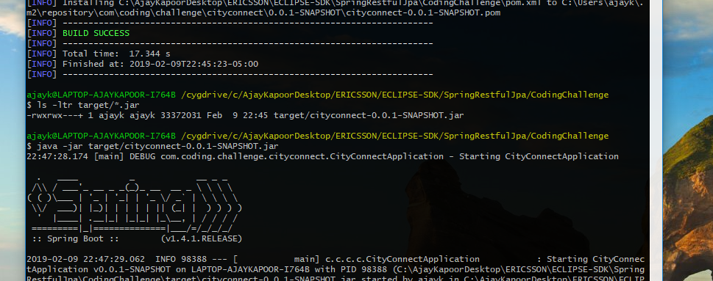

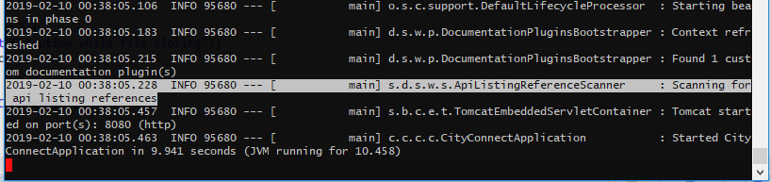

* Test the spring boot application

Go to the Web browser and execute the following commands:

* + <http://localhost:8080/>

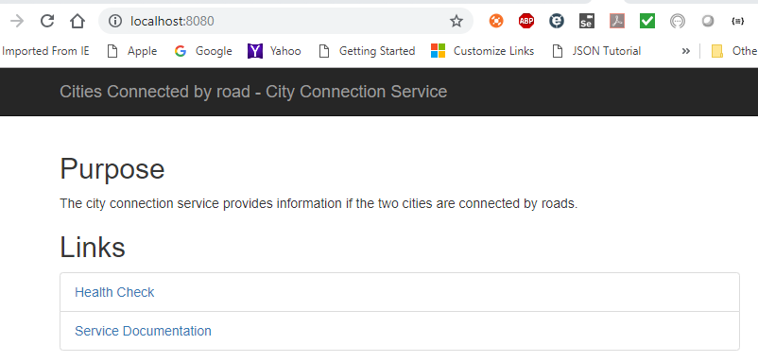

* + Click the Health Check

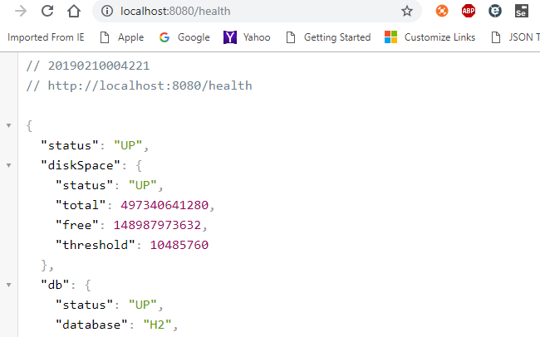

* + Click Service Documentation

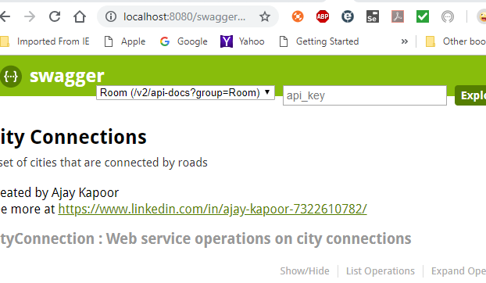

* Check for connections – YES or NO

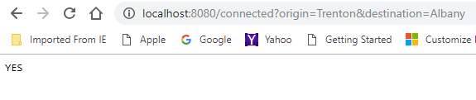

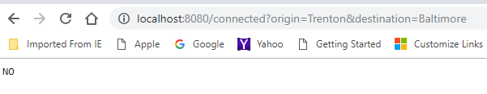

* List the Cities

